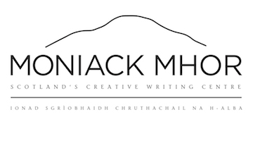
Booking Form
Personal Details
Name: ___________________________________________________________________________________________________
Date of birth: ___________________________________________________________________________________________
Address, including postcode: _________________________________________________________________________
___________________________________________________________________________________________________________
Telephone: _____________________________________________________________________________________________
Email: ___________________________________________________________________________________________________
Dietary, medical or learning needs: __________________________________________________________________
___________________________________________________________________________________________________________

Emergency Contact
Name: ___________________________________________________________________________________________________
Telephone: ______________________________________________________________________________________________
Relationship: ____________________________________________________________________________________________

Parental Permission (for under 16’s)
I grant permission for my son/daughter, ____________________________________________________________, to attend the residential course at Moniack Mhor Writers’ Centre from 30 Nov – 5 Dec 2015.
Printed name ____________________________________________________________________________________________
Signature _________________________________________________________________________________________________
Date _______________________________________________________________________________________________________
Moniack Mhor Writers’ Centre, Teavarran, Kiltarlity, IV4 7HT
www.moniackmhor.org.uk
01463 741 675

