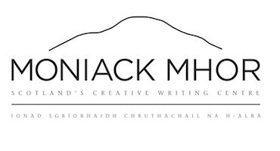
Foirm Tagraidh
Fiosrachadh Personta
Anim : ___________________________________________________________________________________________________
Là-breith : _____________________________________________________________________________ ______________
Seòladh, le còd-puist : ____________________________________________________ _____________________
____________________________________________________________________ _______________________________________
Àireamh fon : _____________________________________________________________________________________________
Seòladh post-d: _________________________________________________________________________________________
A bheil feumalachdan sònraichte ann a thaobh biadh, no a bheil gnothach meidigeach sam bith ann ? : __________________________________________________ ________________
_______________________________________________________ ____________________________________________________
Ann an Èiginn :
Ainm : _______________________________________________________________ ____________________________________
Àireamh fon: ______________________________________________________________________________________________
Càirdeas : _____________________________________________________ _______________________________________
Cead neachd-dìona (fo 16)
Tha mi a’ toirt cead dha , ____________________________________________________________, a bhith ann an làthair aig cùrsa - còmhnaidh Mon Ìothaig Mhòir.
Aimn : _________________ ___________________________________________________________________________
Ainm-sgrìobhte : ________________________________________________________________________________________
Ceann-latha: _____________________________________________________________________________________________
Moniack Mhor Writers’ Centre, Teavarran, Kiltarlity, IV4 7HT
www.moniackmhor.org.uk
01463 741 675

