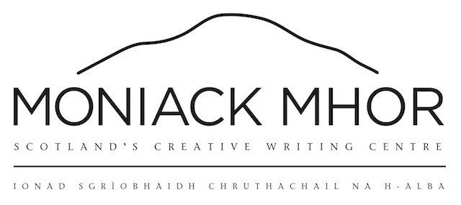

**Grant Application Pack**

Moniack Mhor offers grants to those who may find course fees a prohibitive barrier to attending a course. Generally, we offer grants of between £50 to £300 to those on low income. In exceptional circumstances, we can offer more. We have limited funds per annum for our grant scheme so please only apply if the full fee would prevent you from attending a course.

Please note the following –

* We can only offer one grant per person per annum
* We prioritise those that are applying for a grant for the first time
* We are unable to cover travel costs to and from the centre
* We would like you to feedback after the course by filling in a short evaluation
* We can only support grant applications from UK based residents
* We require three months bank statements, any available proof of means tested state benefits or proof of Disability Living Allowance to support your application
* We are happy to hold your place on a course without a deposit whilst a decision is made on your application. Decisions are normally made within a week.
* We can also offer a payment plan on top of your grant support if successful.

Please provide us with the following information –

|  |  |
| --- | --- |
| NAME |  |
| ADDRESS |  |
| TELEPHONE NUMBER |  |
| EMAIL |  |
| COURSE NAME |  |
| COURSE DATES |  |

ROOM PREFERENCE Single In a twin room

Have you had a Moniack Mhor grant before Yes No

How much would you like to apply for:

£50 £80 £100 £150 

Other amount: Please enter amount here

|  |  |
| --- | --- |
| Annual household income |  |
| Amount held in savings |  |
| Are you in receipt of benefits ? | Yes / No |
| Number of dependents |  |
| Do you have a disability or specific access requirements ? |  |

PERSONAL STATEMENT

Please use this section to explain why you would like to apply for the grant :

Many thanks for taking the time to fill in this form. We will be in contact very soon.