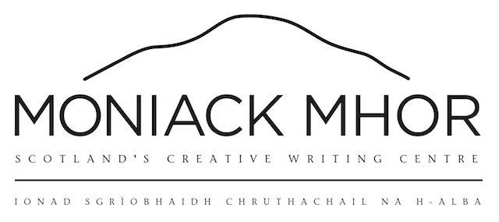
Two Roads Award Application Form

NAME
ADDRESS
TELEPHONE NUMBER
EMAIL
PREFERRED COURSE TITLES
This award entitles you to a fully supported place on a Moniack Mhor 2019 course subject to availability.

Have you received a Moniack Mhor grant before? Yes No

Annual household income
Amount held in savings
Are you in receipt of benefits ? | Yes / No
Number of dependents
Do you have a disability or specific access requirements ?
If your application goes on to be shortlisted, we will require three months bank statements, any available proof of means tested state benefits or proof of Disability Living Allowance to support your application.
PERSONAL STATEMENT
Please use this section to explain why you would like to attend a course at Moniack Mhor and what benefit you believe you would gain from receiving the award:

SYNOPSIS OF YOUR WORK IN PROGRESS
Please use this section to tell us about what you are currently working on:

LITERARY ACHIEVMENTS
Please use this section to tell us about any literary achievements to date, ie short stories in anthologies, awards etc. (if none, just leave blank):

Please note this bursary is open to emerging writers yet to publish a major work.

SAMPLE OF YOUR WORK
Please use this section to paste a sample of your work (a maximum of 2000 words):

