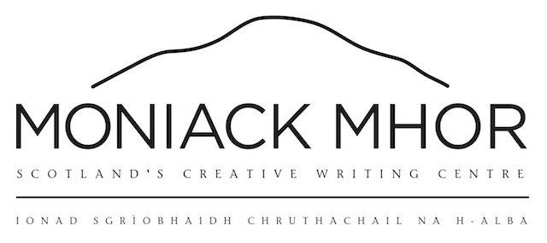

Bursary Application Pack

Moniack Mhor offers bursaries to those who may find course fees a prohibitive barrier to attending a course. Generally, we offer bursaries for up to 50% of course fees to individuals on low income. In exceptional circumstances, we can offer more. We have limited funds per annum for our bursary scheme so please only apply if the full fee would prevent you from attending a course.

Please note the following –
- We can only offer one bursary per person per annum
- We prioritise those that are applying for a bursary for the first time
- We are unable to cover travel costs to and from the centre*
- We would like you to feedback after the course by filling in a short evaluationWe can only support bursary applications from UK based residents
- We require three months bank statements, any available proof of means tested state benefits or proof of Disability Living Allowance to support your application
- We are happy to hold your place on a course without a deposit whilst a decision is made on your application. Decisions are normally made within a week.
- We can also offer a payment plan on top of your bursary support if successful.

Please provide us with the following information –
NAME
ADDRESS
TELEPHONE NUMBER
EMAIL
COURSE NAME
COURSE DATES

ROOM PREFERENCE Single c In a twin room c

Have you had a Moniack Mhor bursary before?
Yes c No c

Are you applying for the A9 bursary ? Yes c No c
* The A9 Bursary can support costs such as travel and childcare.
https://www.moniackmhor.org.uk/writers/grants/

How much would you like to apply for:
£50 £80 £100 £150

Other amount: Please enter amount here

Annual household income
Amount held in savings
Are you in receipt of benefits ? | Yes / No
Number of dependents
Do you have a disability or specific access requirements ?

PERSONAL STATEMENT
Please use this section to explain why you would like to apply for the bursary:

Many thanks for taking the time to fill in this form. We will be in contact very soon.

