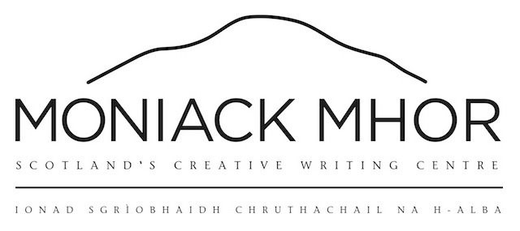
Creativity and Care Programme
Discretionary Fund Application
2024-25

Moniack Mhor’s Creativity and Care Programme offers care experienced young people aged 14-30 in Scotland opportunities to build their creative skills, explore creative opportunities and develop artistic projects.
- Before filling out this form, you can find out more about the fund here: https://www.moniackmhor.org.uk/youth/creativity-and-care/discretionary-fund/
- If you would like to apply over the phone or using a video instead, contact the team using the details at the end of the form!

Name:
Date of birth:
Email:
Contact number:
Address:
Postcode:
How did you find out about the discretionary fund?  Please tick a suitable box | Social media □  Moniack Mhor website □  Email □  Recommendation by friend/parent/guardian/social worker □  Other (please specify) □  ________________________________________
Please confirm that you are care experienced: | Care experienced □  If you’re unsure whether this applies to you, please check the list below or feel free to contact us  Residential / looked after at home / foster / secure / adoption / living with a relative / social work involvement / child or care plan
Have you received funding from the Creativity and Care Programme before?: | New application □  Received funding previously □  If you have received funding from us previously, you may not be able to access funding this time. We aim to offer one funding application per person, per year  If you have received funding previously, do still apply and let us know why you have applied again:
Have you applied elsewhere for funding: | Yes □  No □  If yes where have you applied?  (please specify)  _______________________________________________  If we feel there is an easier way of getting you support for your project, other than our fund, we will happily direct you to organisations that can help you.
Are you applying as an individual or group? | Individual □  Group □  If group, please write the names of the people in your group below:  _______________________________________________
Why would you like this funding?
Here, explain what you would like to do and how funding will help. Check out an example here:

What would the funding be used for, and why?
Here, please include any prices, items you want to buy, names of tutors etc and explain how they will benefit your project.

Copy any links to items, resources, materials or websites here:
How will achieving this funding benefit you?
This can be related to future goals, personal or professional aims...

Reference details:  Please provide contact details for a reference (a professional person who is 18+ who knows or works with you)  This can be foster parent, social worker, teacher or member of your support network | Name:  Relationship to you:  Phone Number:  Email:
Date of application (today’s date):

- Once completed, please send this form to:
Vicky: vicky@moniackmhor.org.uk , 07513 805 436
Roxana: roxana@moniackmhor.org.uk
- Remember, if you have any questions or would like to talk things through, you can contact the rest of the team on the below:
Office: 01463 592828
Edel: edel@moniackmhor.org.uk, 07354 590 314

The Life Changes Trust was established by The National Lottery Community Fund in April 2013 with a ten year endowment of £50 million to support transformational improvement in the quality of life, well-being, empowerment and inclusion of three key groups in Scotland: people living with dementia, unpaid carers of those with dementia and young people with care experience. The Trust concluded its ten year tenure in March 2022. Moniack Mhor is a formal legacy partner of the Life Changes Trust.

