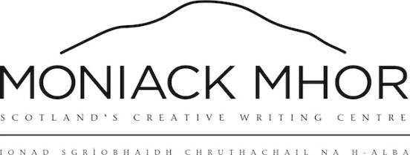

Young Funders: grant application form
Thank you for your interest in applying to our Young Funders grant! Please fill in this application form:
Contact details
Name
Date of Birth
Email address
Phone number
Address
Postcode
How did you find out about the Young Funders programme? | Social media o  Moniack Mhor website o  Email o  Recommendation by friend/parent/guardian/social worker o  Other (please specify) o ________________________________________

Moniack Mhor’s Young Funders Programme lets care experienced young people in Scotland build their creative skills and develop artistic projects.
You may apply for any support, usually worth up to £500, for a creative project you are involved in, or would like to start.
How this will work: you provide us with details of what you want, and a rough idea of the price, and we will arrange it for you. Examples of what you might like to apply for may include:
- Access to mentors with professional experience
- Equipment
- Transport to get to workshops or lessons
- Recording or publishing costs
- Opportunities to showcase your work
You can also apply as a group for collaborative projects, with a cap of around £500 per person in the group.
When you have applied, our steering group of young people, ‘Moving with Moniack’, will assess the application and we will get back to you. Your application will be anonymous while it is being looked at by the group.
How would you prefer to be contacted by Moniack Mhor once your application has been looked at?
Email o Phone/WhatsApp o Social media (please specify) _________________________________ o Other (please specify) _________________________________ o

Funding application
Please tick this box to confirm that you are care experienced o
(If you are unsure whether this applies to you, feel free to contact us and ask, or check this page on the WhoCares? Scotland website: https://www.whocaresscotland.org/what-we-do/participation/)

If you have been awarded funding for the Young Funders Programme before, we will usually be unable to offer it again this time. Please tick this box to confirm you haven’t had funding from us before o
If you have received funding from us before, but would like to apply again, please write a bit about why you wish to reapply:

Have you applied anywhere else or looked elsewhere for this funding?
Yes o No o
If yes, where have you applied? (N.B. If we feel there are easier ways to get support for your project than our fund, we will be happy to direct you to organisations that can help you)

Are you applying for an individual or a group grant?
Individual o
Group o
If you are applying for a group grant, how many are in your group? _____
Please list the group members and their contact details:

Please summarise your application here. Write what your project is, what you would like to apply for to support it, and an idea of the price. If you like, you can also send us samples of your work (eg. a video explaining your project, photos, recordings, or other samples), though this is not compulsory:

How do you feel the funding would help develop your project from the shape it’s in at the moment?

How do you feel receiving funding for your project would impact you as a person, and your future goals?

Date of application (today’s date):

If your application is successful and you accept funding from us, we ask that you agree to give us some feedback about how you are getting on with your project. We will probably contact you a few weeks or months down the line, depending on the nature of your application.
Please send your form to youngfunders@moniackmhor.org.uk. Contact Charlotte or Andy using the details below if you have any questions.
Charlotte: charlotte@moniackmhor.org.uk or 07510475340
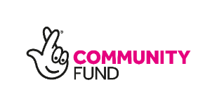
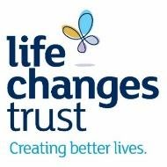
Andy: andy@moniackmhor.org.uk or 07741910999
The Young Funders programme is supported with funding from the Life Changes Trust. The Trust is funded by the Big Lottery.

