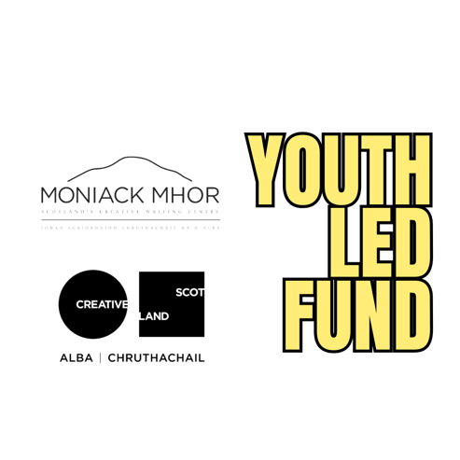

GROUP APPLICATION FORM

Thank you so much for applying to the Youth Led Fund!
And please don't worry about spelling and which words you use.
The application form is divided in four sections:
- General Information
- Your creative idea
- Showcasing Opportunity
- EDI Data (a separate form, this is the link to it)
More info about the fund and the eligibility criteria can be found on our website: https://www.moniackmhor.org.uk/youth/creative-scotland-youth-led-fund/
If you need help filling out your application, please get in touch with us on youthfund@moniackmhor.org.uk.
This information will be held securely by Moniack Mhor and not shared with any third party.

General Information

Names of all group members:

Name of Group/Collective (if you have one):

Ages of all group members:

E-mail Address (or phone number, if you'd rather be contacted via phone):

Where are you currently based in Scotland?:

Is this a reapplication? (Are you applying for a second time with the same project?): Yes | No

Are you 16 and under or someone is filling this out with you? (Please skip to ‘Your Creative Idea’ if this is not applicable to you) (If it applies, highlight the relevant answer)

Yes, we’re under 16 and someone is helping us
Yes, someone is helping me

What is your name and your relationship to the applicants?

For those under 16 with someone helping
Will you be present or available during the project to offer support and ensure safety?

Have you or will you complete any safeguarding checks required by your role (e.g. PVG, if appropriate)? If relevant.

How will you support the young people in managing any risks (e.g. travel, materials, online activities)?

Are there any specific concerns we should be aware of to help support this young people safely?

If the project involves online activity, how will you help the young people stay safe?

I confirm I have read and understood the safeguarding responsibilities mentioned in the questions above and will ensure theses young people’s safety during the project. (Please highlight the relevant answer)

Yes
No

Your creative idea
We're excited to hear more about your creative idea in this section. Please be as detailed as possible, as this is the section that we mainly base our decision on. If you require assistance, please get in touch. The word count is a general guidance, we understand you sometimes go over or slightly under word count and will consider this.

Tell us about yourself as a group and your creativity, around 150 words.
This is the part where we’d like to get to know you better as a group.
- What brought you together as a group? Share what makes you excited creatively? What inspires you? What creative activities do you enjoy?
- Do you have a shared idea/a goal that unites you? Do you meet regularly and what do you meet for?

What would you like to use the funding for? Around 300 words with the focus on part a.
- Tell us more about your creative idea.
- This is where we'd like you to share what you'd like to do with the money, we don't require a detailed budget, but please give us a total amount needed to complete your idea.

How would the funding address challenges you face in participating/pursuing your creativity? Around 150 words.
How do you think receiving the funding would help remove barriers to achieving your creative potential? We have added definitions of isolation and marginalisation to our website.

How would the funding benefit you or others beyond the project? Around 150 words
This is where we'd like you to share what impact the funding would have for you or others. For example, develop skills, socialising, creating community and more.

Have you considered the materials you may need for your project come with possible risks while using for example craft knives, heavy tools? (Please highlight the relevant option)

Yes
No

If successful, how would you like to receive this funding? (Please highlight the relevant option)

Bank Transfer
Items ordered/classes paid for on your behalf

If you chose ‘Bank Transfer', please give us your bank details. Full Name (as it's shown on your card), sort code and account number.

If you chose ‘Items ordered/classes paid on your behalf’, it would be brilliant if you could give us relevant links to items/classes, that would be very helpful. If you need help doing research, just let us know.

If you'd like something ordered to your house, please give us your address.

Is there anything else you'd like to ask/tell us about?

Showcasing Opportunity
At the end of this project, we're planning to share outcomes of the people who have received funding. Whether you would like us to showcase your work or not, please be assured this won't affect our decision.

Would you be interested in us showcasing your work? (Please highlight the relevant option)

Yes
No
Maybe

Would you be interested in coming along in person to a showcasing event? (Please highlight the relevant option)

Yes
No
Maybe

